Luca Csepely-Knorr

Manchester School of Architecture

**Fischer, József (1901-1995)**

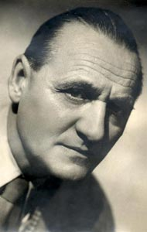

József Fischer

<http://archivum.epiteszforum.hu/holmi_detailed.php?mhmid=637>

József Fischer was a prolific designer of mid-war Hungarian modernist architecture, and alongside Farkas Molnár, he was also a highly active and important member of the Hungarian section of the CONGRÈS INTERNATIONAUX D’ARCHITECTURE MODERNE (CIAM). He started studying architecture at college and enrolled at the Hungarian Academy of Crafts, but later had to leave it for financial reasons. He started his own practice in 1930 with his wife Eszter Pécsi who was the first Hungarian female engineer, and also an internationally recognised structural engineer.

Fischer was highly influenced by the achievements of socially conscious architecture, the housing programmes of the social-democratic Vienna, and the principles of the BAUHAUS. He remained a propagator of social aspects of architecture throughout his life, and remained an active member of the social-democratic party.

Among his economical, but sometimes rigid early modernist villas, the Hoffmann Villa was published as “Home of the Month” in the *Architectural Review* in 1935 and in the journal *Decoration* in February, 1936. By the end of the decade his buildings had become more influenced by the decorative industrial arts, such as the Villa Járitz or the Hotel Gyopár and Hotel Rege on the Buda hills. He was part of the architectural team that designed the so-called OTI (Országos Társdalambiztosító Intézet) apartment blocks in Budapest in 1934, an alternative, modernist version of a block of flats for the capital.

For a short period between 1934 and 1935 he collaborated with FARKAS MOLNÁR and MARCEL BREUER. The success of the cooperation was marked by a winning entry to the architectural competition for the area and pavilions of the Budapest International Fair in 1934. Fischer also cooperated with Molnár on the buildings of the Workers Hospital of the National Insurance Company (Országos Társdalambiztosító Intézet) in Pestújhely, Budapest.

After the Second World War, between 1945 and 1948 Fischer became responsible for the re-building of the capital and was appointed president of the Budapest Board of Works. He directed the planning process of the Greater-Budapest regulation plan in 1946, which shows the influence of and a similar thinking to Abercrombie’s Greater London plan. In 1947 Fischer presented the plan during the 5th Congress of CIAM.

After the dissolution of the Budapest Board of Works, Fischer worked for the Budapest City Planning Office (BUVÁTI) and directed renovation works in Budapest. As he did not have a University degree, he was deprived of independent architectural works. His wife emigrated to the USA in 1958 and Fischer was allowed to follow her in 1964. He died in Budapest in 2005.

**List of Works**

1931 Family house, Napraforgó street, Budapest, Hungary

1932-35 OTI Apartment block, Budapest, Hungary (together with Bertalan Árkay, Sándor Faragó, Károly Heysa, Pál Ligeti, Farkas Molnár, Móric Pogány, Gábor Presich, Mihály Vadász)

1933-34 Villa Hoffmann, Szépvölgyi út, Budapest, Hungary

1934 OTI Workers Hospital, Budapest, Hungary (together with Farkas Molnár)

1940 REGE Hotel, Budapest, Hungary

1941-42 GYOPÁR Hotel, Budapest, Hungary

1941-42 Villa Járitz, Budapest, Hungary

**References and further reading**

Apáti-Nagy, M. (2001)‘Száz éve született Fischer József’. *Új magyar építőművészet* (2) pp. 22-23.

Ferkai, A. (1998) ‘Hungarian Architecture between the Wars’. In Wiebenson, D. and Sisa, J. eds. *The Architecture of Historic Hungary.* Cambridge, MA: The MIT Press. 245-274.

Polónyi, K. (1995) **‘**Fischer József emlékezete’.*Magyar építőművészet* 86 (4) p. 60

**Visual material:**

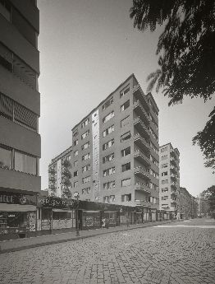

**OTI Apartment Blocks, Budapest, 1934.**

Bertalan Árkay, Sándor Faragó, József Fischer, Károly Heysa, Pál Ligeti, Farkas Molnár, Móric Pogány, Gábor Presich, Mihály Vadász

Copyright:

<http://php52.epiteszforum.hu/files/imagelist/fry6g2_1.jpg>

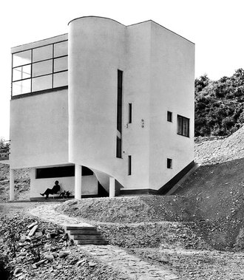

**Villa Hoffmann, 1933-34**

Copyright: E. Sípos

http://static.nol.hu/media/picture/71/03/10/000100371-5819-330.jpg

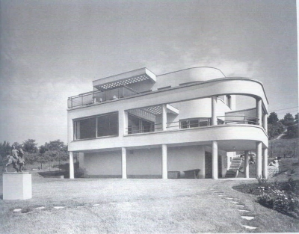

**Villa Járitz 1941-42**

Copyright: Forster Gyula Nemzeti Örökséggazdálkodási   
és Szolgáltatási Központ

http://egykor.hu/images/2010/original/budapest-jaritz-villa.jpg

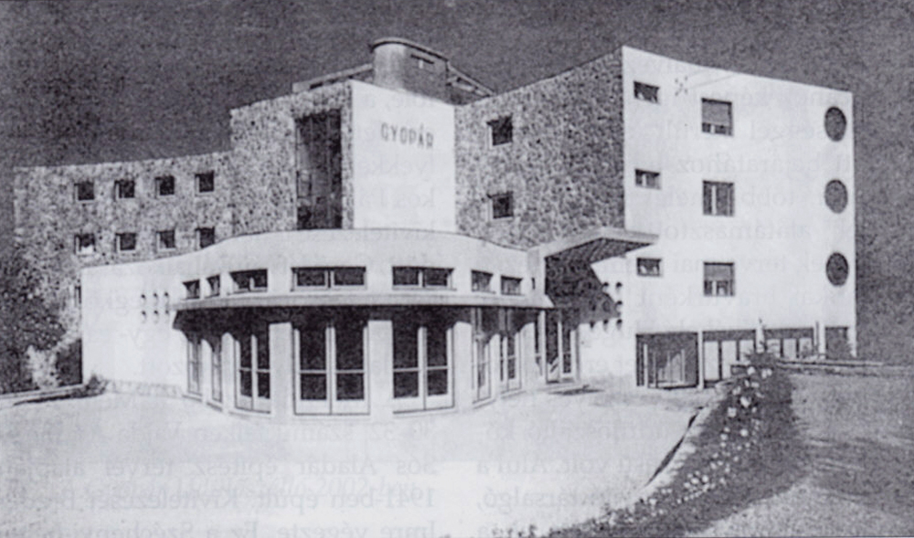

**Hotel Gyopár, 1941-42**

Copyright:

http://egykor.hu/images/2010/original/budapest-xii-kerulet-szot-szabadsag-udulo-_15.jpg